Project # 3 EE596

Mohammad Chahardori

ID:11632753

Due Date: Sun: 03/09/2019

Points: 100
Make cadence schematic for comparator.
Use 1-stage opamp in the preamplifier with strong-arm latch with VDD = 1.3V supply.
1. Design (20 pts):
Use C = 1 pF for storing offset and use output-offset cancellation (preferred). You can design your own pre-amplifier and latch using reference works from IEEE Explore and Class Notes.
Highlight the following in your design choices through analysis (and using block-level simulation to verify):
------------------------------------------------------------------------------------------------------------------------------------
- a. Input offset voltage (show through analysis only – dependent on your W and L of your preamp).
- For the preamplifier the overall offset can be calculated from:
On the other hand, as the main source of offset in preamp is equal to:
In 130 nm CMOS technology the value of as a result for the design preamplifier which has W=7um and L=0.12um the value of which leads to . Therefor we expect to see offset voltage of much higher than 33mV since the overall offset is :
On the other hand, because of the structure of preamp the gain of Preamp is less than 10 which can not completely remove the effect of latch offset. Anyway, since we are using output offset cancellation, we mostly would not see the effect of preamp offset and the major offset is because of latch offset which is not removed by offset cancellation structure.

- b. Bandwidth of the preamplifier
In general form, the BW of the deployed preamplifier with diode connected load can be calculated from:
Where the C_{in_latch} is the input capacitor from strong arm latch following the preamp and C_{db} and C_{dg} are parasitic drain-gate and drain-bulk capacitors of all transistor connected to the pre amp output. In the designed comparator, the BW of preamplifier should be large enough to let the output of Preamp reach (settle) to the required value in the half of clock cycle time when the minimum voltage difference applied to the comparator. Since the positive feedback of the latch helps the output to reach the required final value in shorter time compare to normal high gain comparator without cross-coupled structure, we don’t need very high bandwidth for Preamp, so it is better to find the required bandwidth of preamp using simulation when we add the latch at the output of the comparator. In the following figure the AC response of preamplifier is shown. Simulation shows that the preamp works properly with 1 GHz clock frequency when it has 3dB BW around 1.25GHz and UGBW of 8 GHz when the DC gain is 18dB.
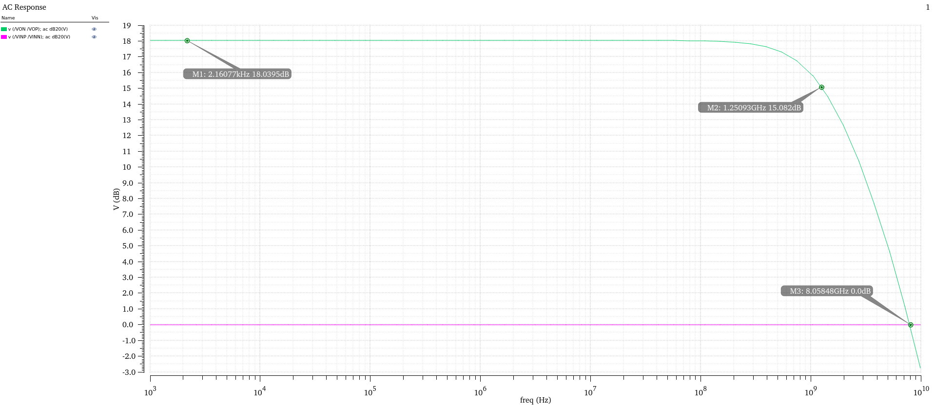
AC response of preamplifier

- c. Power of the preamplifier

To calculate the total power the transient current and based on that the average of the power supply current and average power when 1GHz clock signal has been applied to the comparator calculated by cadence software as shown in the bellow figure. The average power consumption using 1.3V supply voltage is 479uW.

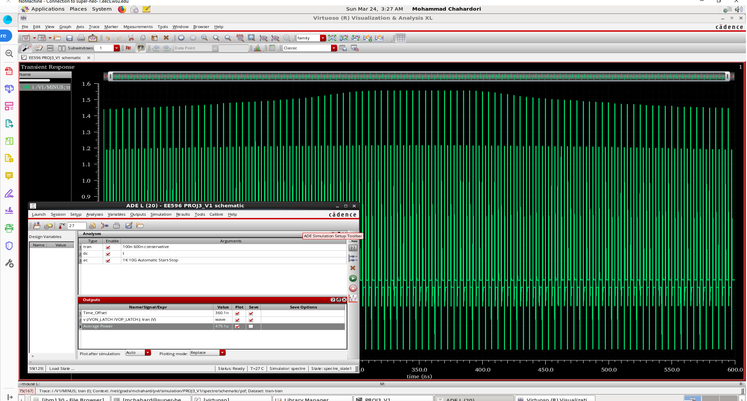

- d. Time-constant of the latch

- The time constant of the comparator includes two parts. Time constant of preamp and time constant of latch. We have:
- and for latch we have:
- Please note that the cross-couple structure has positive feedback so the time constant of cross couple transistor appears at positive exponential function which increase the speed of the comparators. In the following figure the output of comparator which include the time constant of both pre amp and latch together is shown.
- 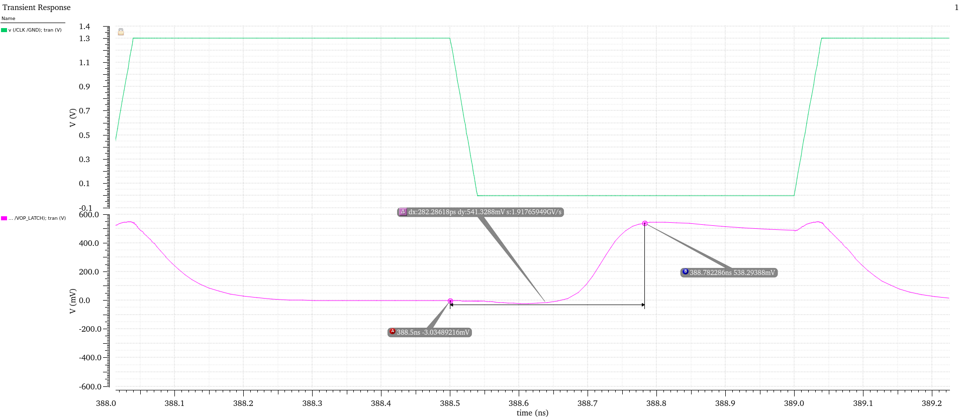
- as we can see the settling time is about 282ps for 10mV differential input voltage which includes the settling tine of both preamp and latch. In fact, the overall time constant is combination of these to process but it is not equal to summation of them.

- e. Leakage current in the latch (leave the supply connected but disable the clock) (in the off-state)

In the following figure the current consumption and power consumption of the circuit when CLK is zero has been shown.

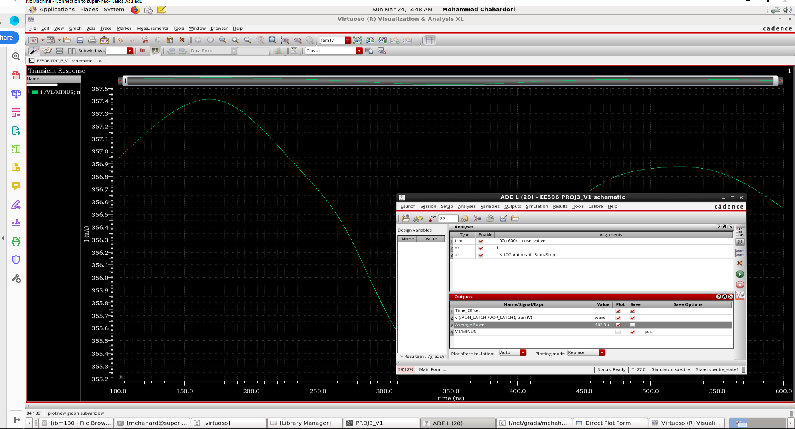
As we can see the current consumption in CLK=0V is around 356uA and is not dependent of input voltage. Also, since the comparator structure has DC bias the operation of comparator includes static and dynamic power.

2. Testbench Setup (10 pts)
Generate clocks from VDD to VSS with rise and fall times of 40 ps. Use clock frequency of 1 GHz. Show the testbench schematic clearly with the DC / AC / Tran sources.

Structure of the comparator along with the sizing of the components have been shown in the following figure. It consists of preamp and input switches and latch and offset cancellation switch at the output of the preamp.

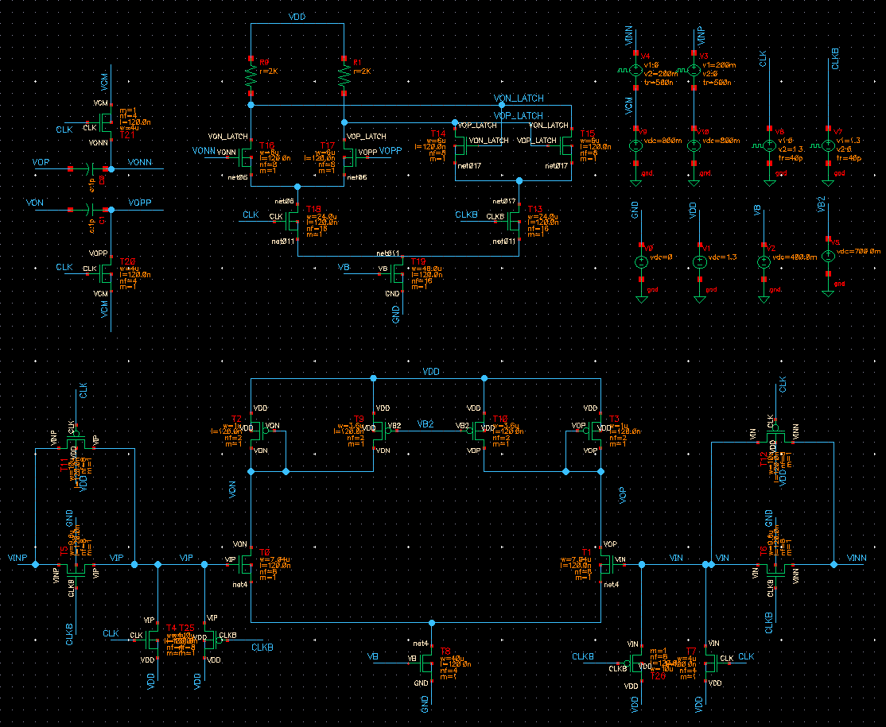

3. Observations to report from DC simulation (10 pts)

a. Show DC voltage of the preamp in schematic (with proper i/p biases)
In the following figure the DC operating points of different components of the circuit have been shown.

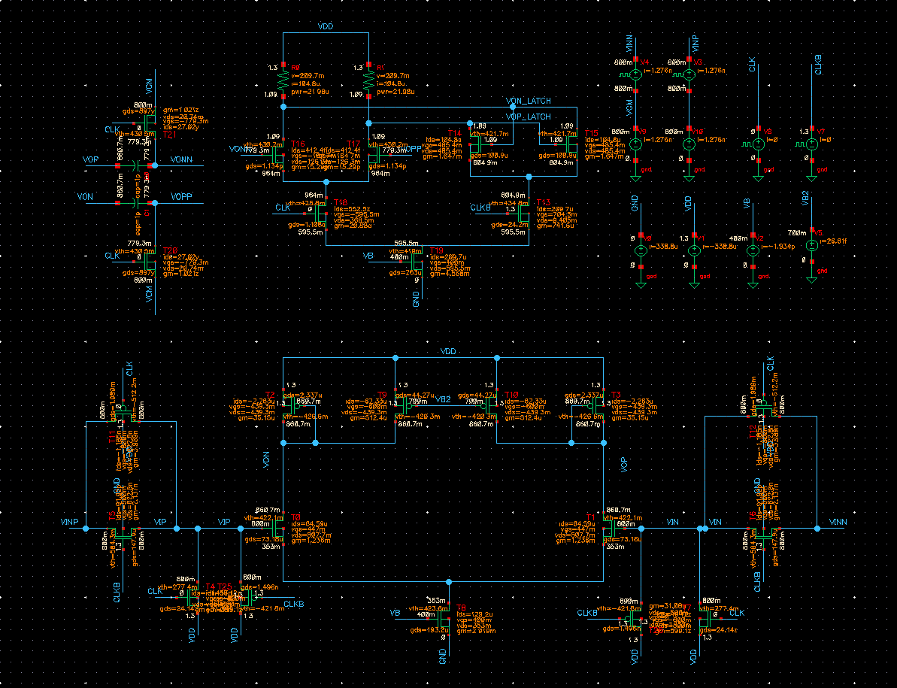

b. Report DC Gain, 3dB BW and unity-gain bandwidth of the open-loop preamplifier.
In the following figure the AC response of preamplifier is shown again! Simulation shows that the preamp works properly with 1 GHz clock frequency when it has 3dB BW around 1.25GHz and UGBW of 8 GHz when the DC gain is 18dB.


AC response of preamplifier

4. Observations to report from transient simulation (40 pts) :

- Fig. 1: Show clock waveform of the preamp and latch clearly (5 pts)
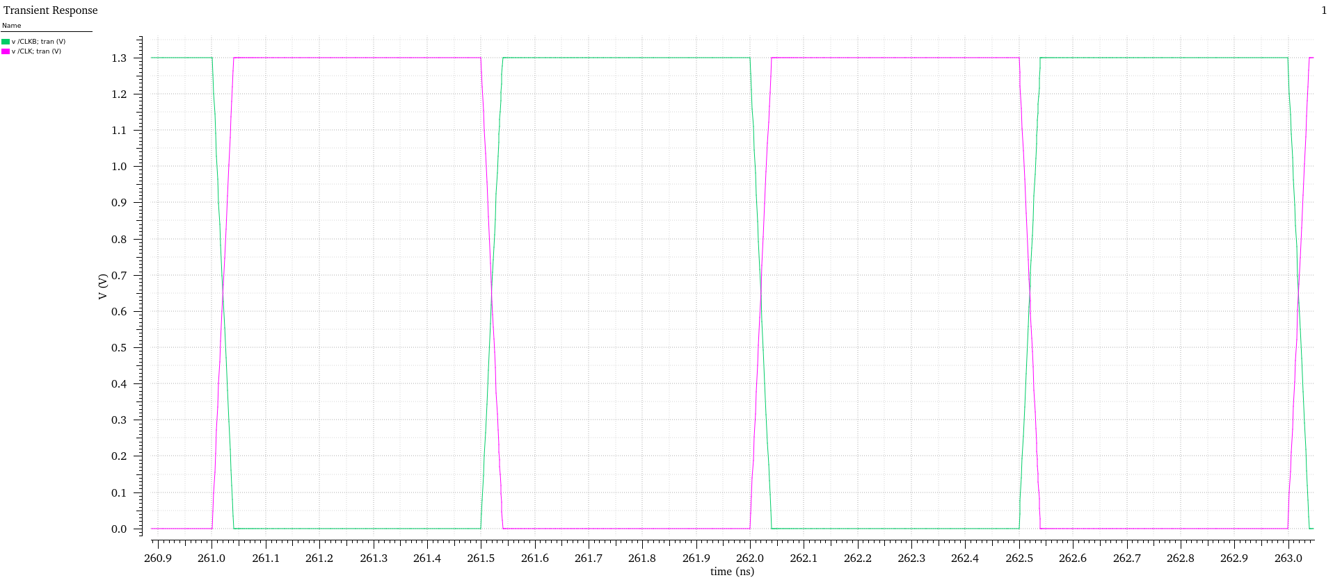
CLK and CLKB

- Fig. 2: Show the input, preamp output, latch output with clock waveform clearly (5 pts)

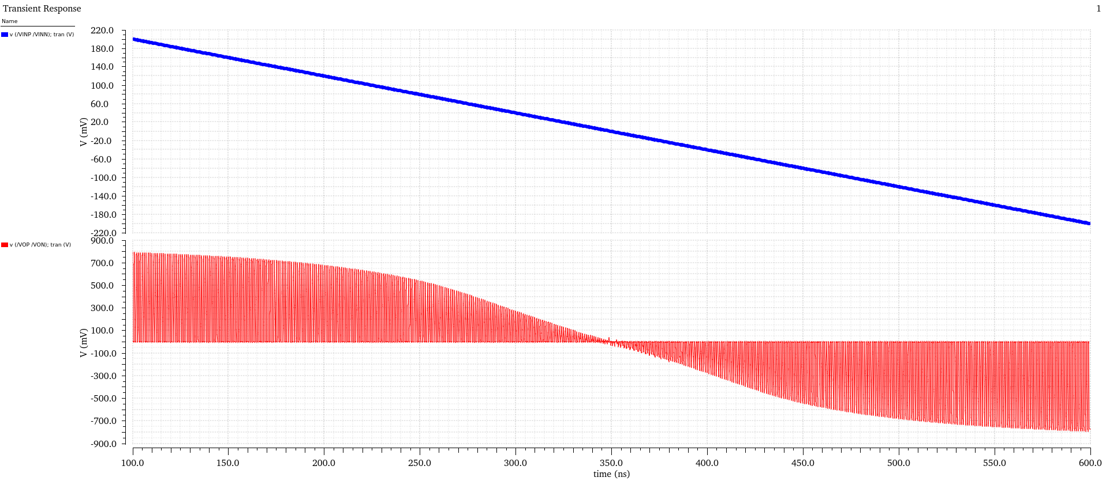
a. Blue curve is input, and red curve is output of preamp.

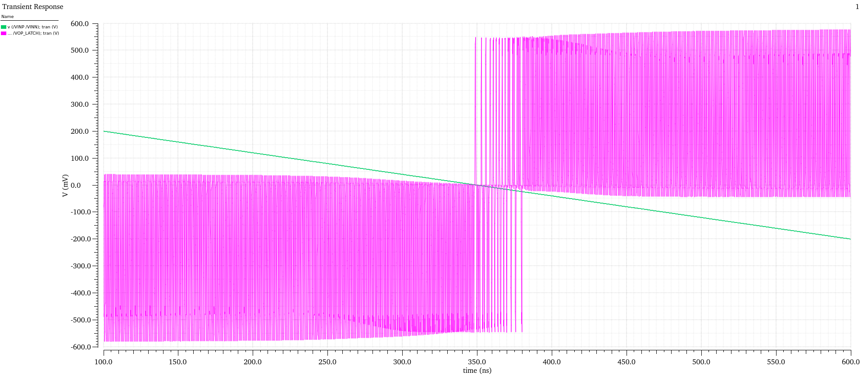
b. Green curve is input, and pink curve is output of latch when the reference of comparator is equal to bias voltage and input voltage varies from 200mV to -200mV around bias voltage .

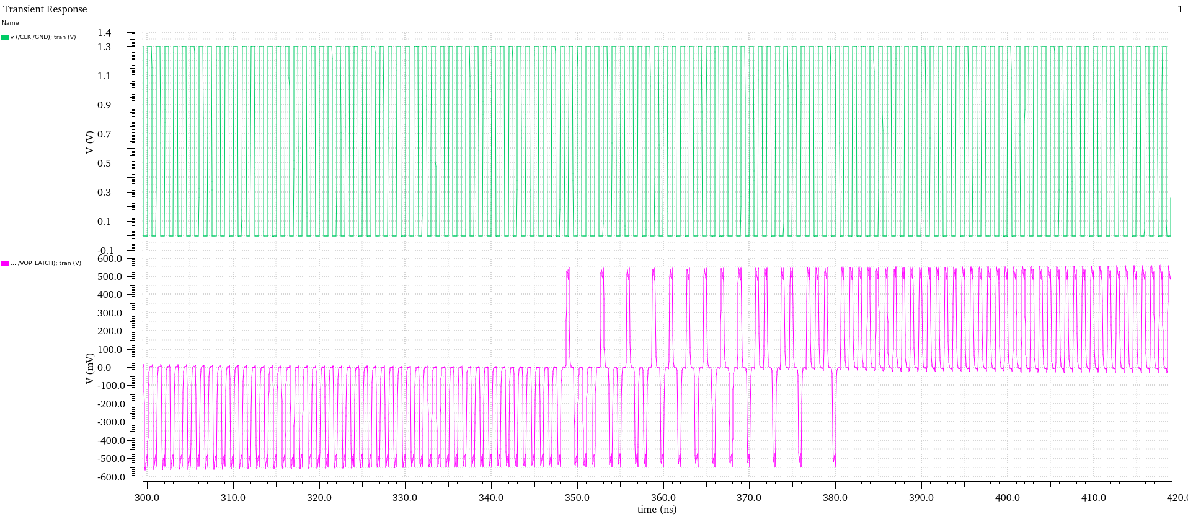
c. Green curve is CLK, and pink curve is output of latch when the reference of comparator is equal to bias voltage and input voltage varies from 50mV to -50mV around bias voltage which is correspond to 300ns to 420ns.

c. You will add additional figures to show your performance

In addition to the above figures, please verify and report the following:
- d. The charge injection (CI) error by measuring V’’ 0.1 ns before and 0.1 ns after Q1a turns OFF (note Q2 is OFF).
The structure of comparator which I have designed is different from the structure you have discussed in the class, so the name of the nodes and components are different. Anyway, in the following figure I have shown the effect of CLK change on the output voltage at rising and falling edge of the clock signal. It seems that in the rising edge of the CLK the comparator output suffers 59 mV variation, but it is not very important since at this moment comparator start equalazition phase not comparison phase. In falling edge of the CLK comparator suffers less than 5mV variation at the output of the latch at the beginning of the phase comparison phase. This amount would be act as an offset with less than 0.1V at input since:

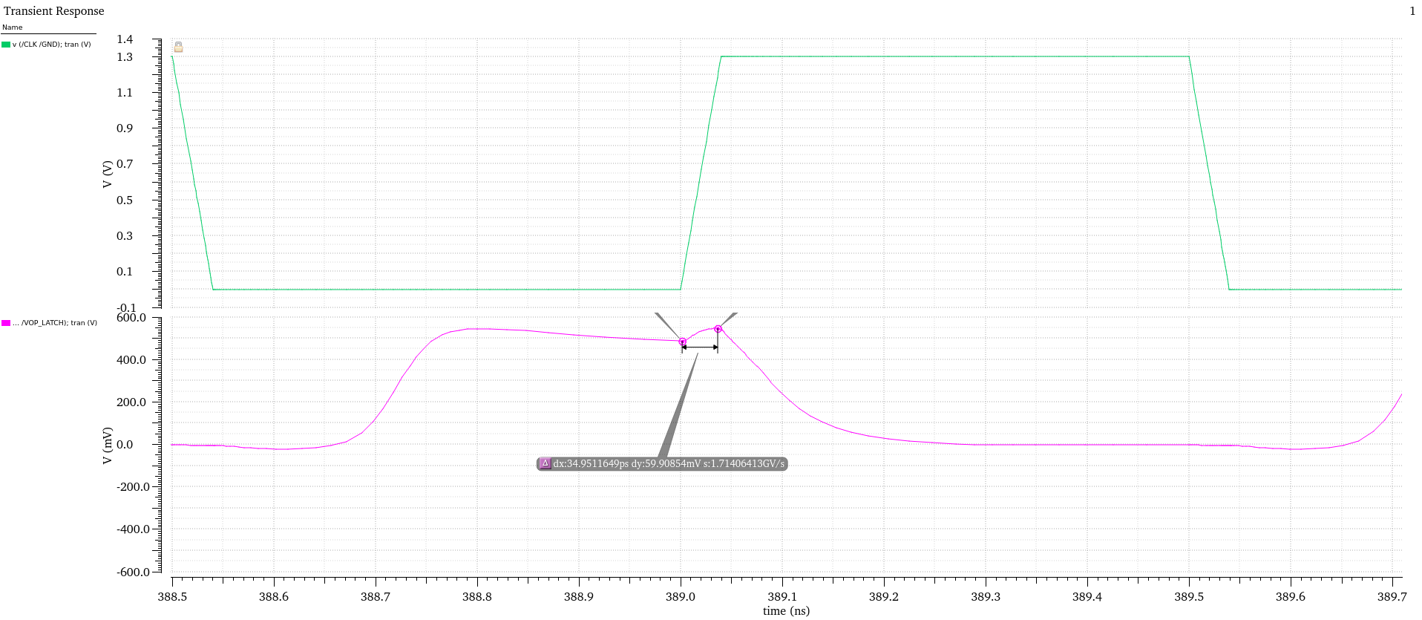

- e. Reset phase settling time: with Vin = +0.5 V, measure time for V’ and V’’ to settle to < 10mV of its final value.

- As shown in the bellow figure, the reset phase settling time for less than 10mV error at the output is 237ps. When the Vin is 100mV. For larger Vin up to 500mV the reset settling time does not exceed 370ps.

- 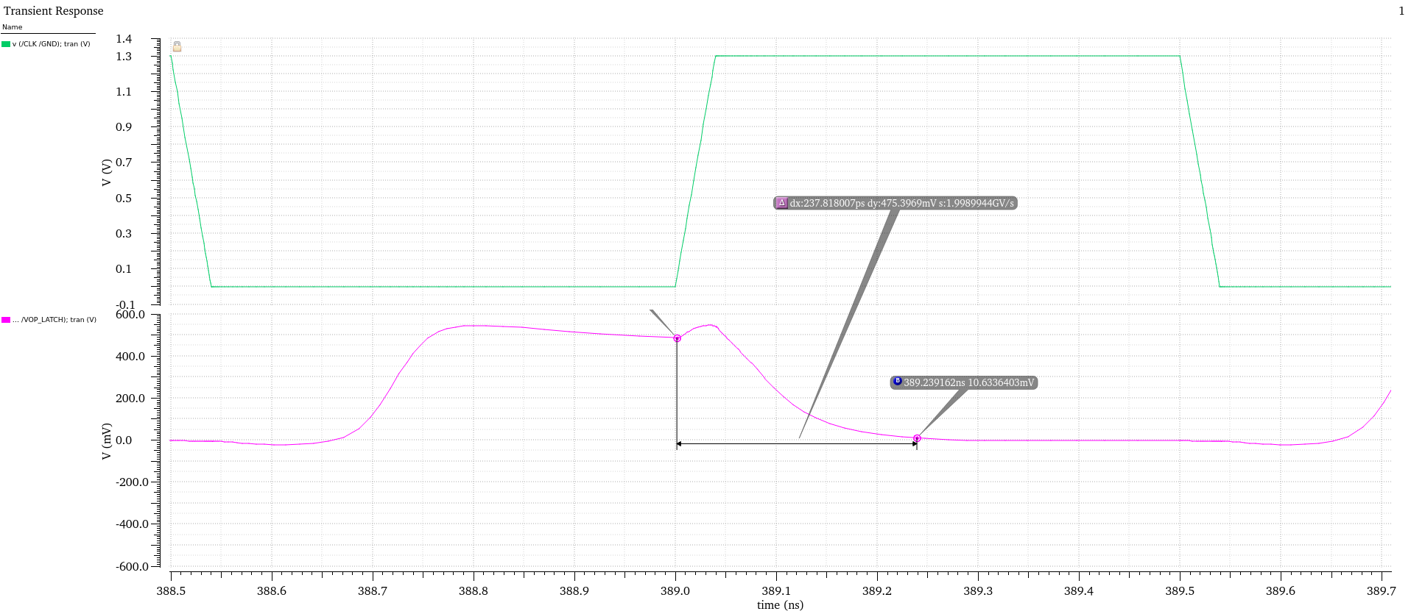

- f. Comparator phase settling time

- As shown in the bellow figure, the comparison phase settling time for less than 10mV error at the output is 282ps when the input is 100mV.
- 

- g. With Vin set to 50 mV, measure how long it takes for the output to reach > | 1.0 V|.

The designed comparator is a fast resistive-load latch. The output varies from 0 to 550mV according to the value of resistor (2K) and current consumption of comparator part which is around 220uA. In this case, to answer this part,a I consider the time required to reach 80% of final value. This delay is about 175ps.

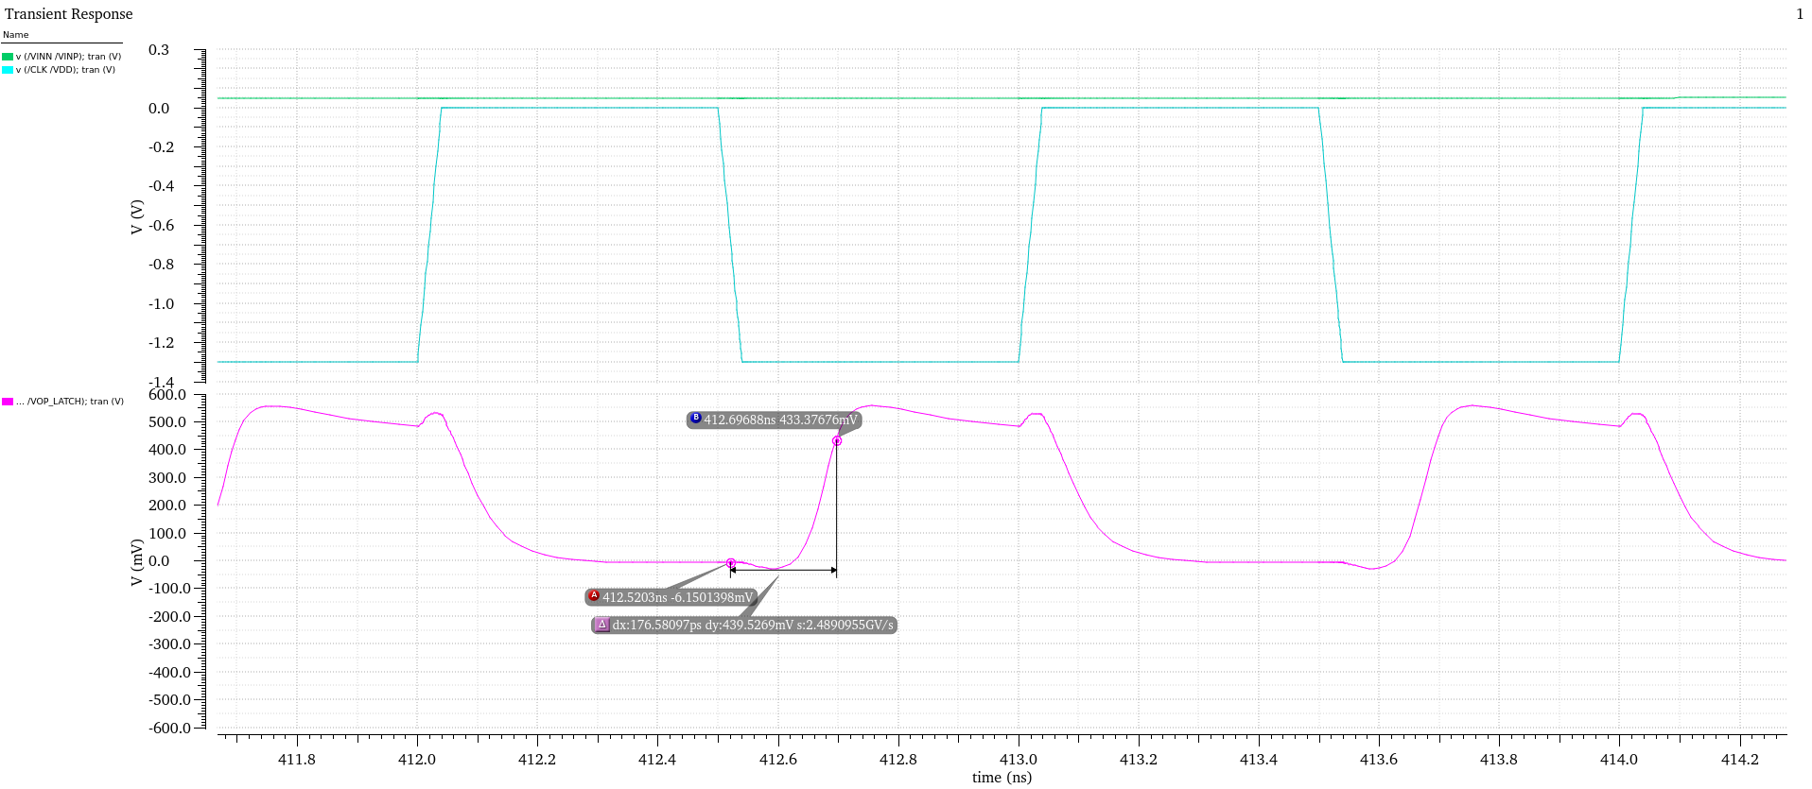

- h. How long does it take to reach > | 1.0 V| if the compensation capacitor is not switched ( tie gate of compensation FET Q1 to VDD).
I don’t have the structure of your comparator !!! you said that we can use any desired structure from IEEE papers.

i. Change clock amplitude to 0.9 V and measure CI error.

The designed latch can not work properly with 900mV clock. I have simulated the circuit with 1.2V clock voltage instead. As it is seen the charge sharing in that case in rising edge reduce to 49mV and in falling edge of the clock it is very small. (Less than 4mV )

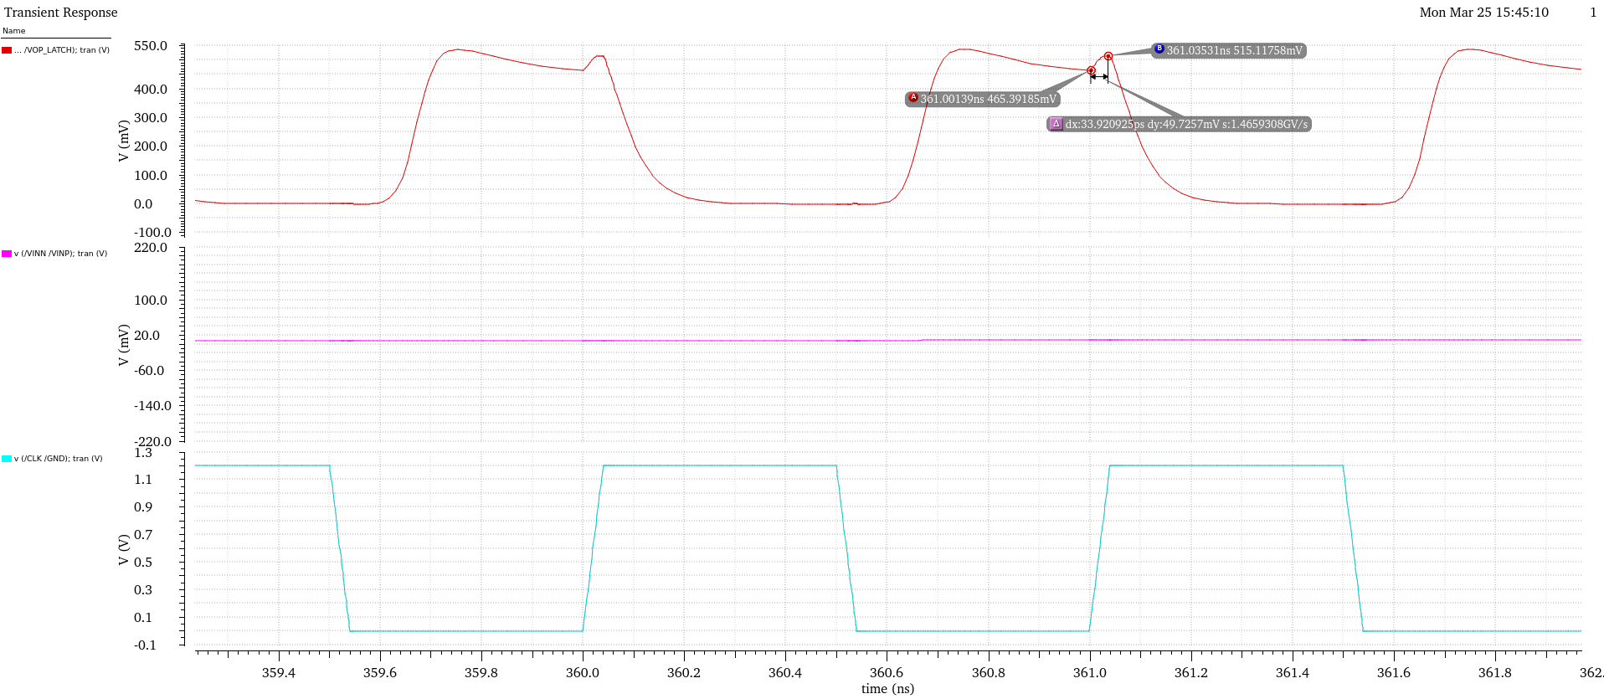
5. Observations to report from Monte-Carlo simulation: (20 pts)
a. Run monte-carlo simulation with the latch and the preamplifier included. For setting Monte-Carlo, use ADE-XL or ADE-Explorer and use 100 iterations with random mismatch. Your IBM model is Monte-Carlo compatible. Report the variation in the input-offset of the comparator with the latch in operation.
In the following figure the Monte-carlo simulation result has been depicted. It seems that from 100 iterations only 68 iterations have generated result. Also the standard deviation and mean are 164ns and 229ns. However several samples happened at the beginning of the simulation at 100ns which are not correct. If we don’t consider these sample the mean is about 380ns and the variance is about 70ns. Since the zero voltage happens at 350ns (correspond to zero offset) in our simulation and the input ramp has 400mV variation in 500ns (each 1ns from the reference is equal to 0.8mV) the offset mean and variance correspond to 380ns and 70ns are around 24mV and 56mV respectively.
